

# DSA30BT PROJECT 2022

**Team Members**

|  |  |  |
| --- | --- | --- |
| Surnames | Initials | Student numbers |
| Sibiya | S | 216537971 |
| Dladla | SD | 218682413 |
| Simelane | T | 219230672 |

ACTIVITY 1

Purpose

We are tasked to write a script that will run as soon as the user login into the Linux Server VM. We have to append the script at the end of the start-up file called ***.bashrc***; the script will prompt the user to enter the username, then ask for the user’s password. The script will then test if the username and password entered by the user are correct, if both username and the password are correct then the script will display a message saying “Login successful” and after 3 seconds it will display either a (“Good morning user Welcome to DSA30BT Presentation! ”, “Good afternoon user Welcome to DSA30BT Presentation!”, or a “Good evening user Welcome to DSA30BT Presentation!”) message to the user and if the username or password is incorrect the script will display a message saying “Login invalid!”, and logs you out of the sever after 4 seconds.

Steps:

Downloading cowsay

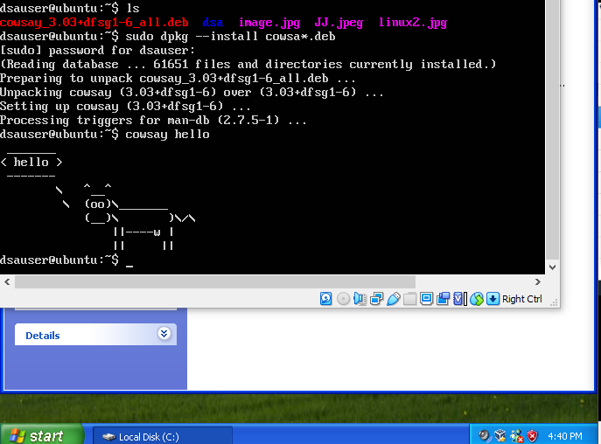

Installing cowsay:

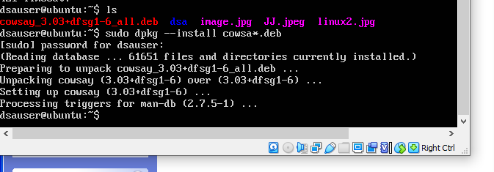

Uploading cowsay

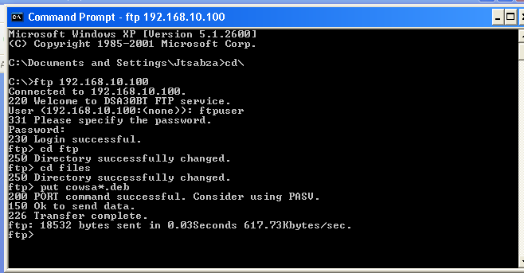

Script commands:

echo “Enter username”

read user

echo “Enter password”

stty -echo

read pword

stty ech

if [[ ($user == dsa” && $pword == “1234”) ]];then

echo “Login Successful”

else

sleep 3

echo “Login Invalid”

sleep 4

logout

fi

time=$( date “+%H )

if [ $time -lt 12 ];then

cowsay -f dragon Good Mornoing $user

elif [ $time -lt 18 ];then

cowsay -f gnu Good Afternoon $user

else

cowsay ----f turtle Good Evening $user

fi

**Output:**

Command to access the script

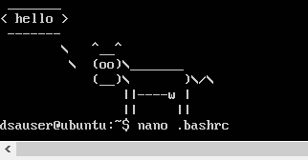

Bash script

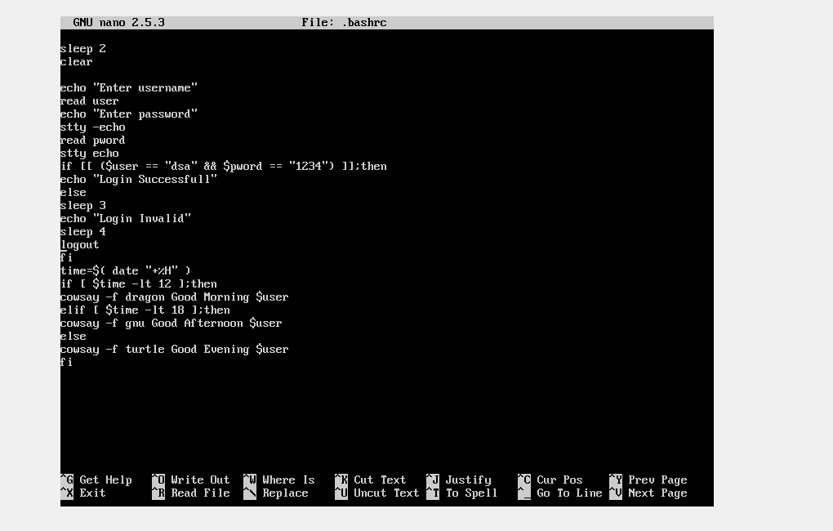

When user login successful

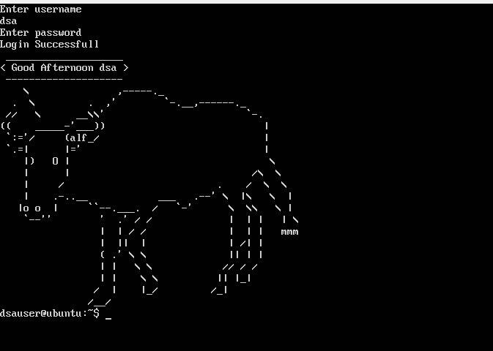

**ACTIVITY 2 FTP ACCESS**

**Task 1: Setting up the VMs**

Installing windows XP

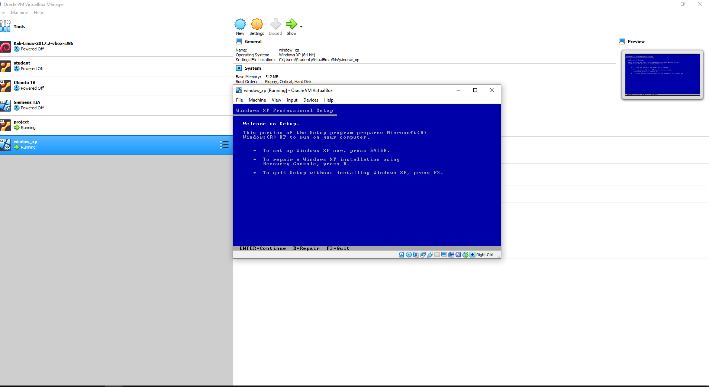

Importing server to VM

We imported the Ubuntu server that was provided to us on brightspace. We then installed a software called putty which will allow us to connect ftp to the server, and be able to transfer the group picture and linux based picture from the windows vm to the server.

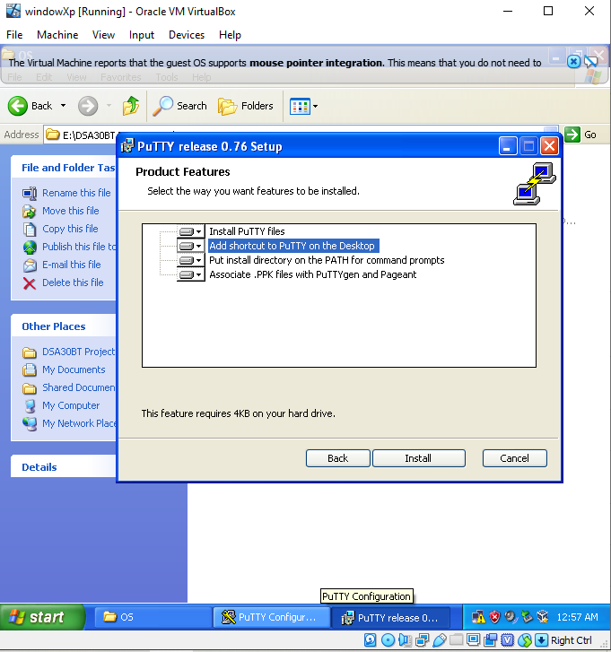

Purpose:

We are tasked to set windows XP and Ubuntu server network; we have to assign IP addresses of the virtual machines manually. We will create a NAT network on the VM, by pressing the file button on the top left of the VM, select preferences and a small virtual box window will pop up. After we have set the Nat network up, we will then have to implement the NAT network on both the windows XP machine and the Ubuntu server. The screenshot below shows how we went about create

Setting up the IP address

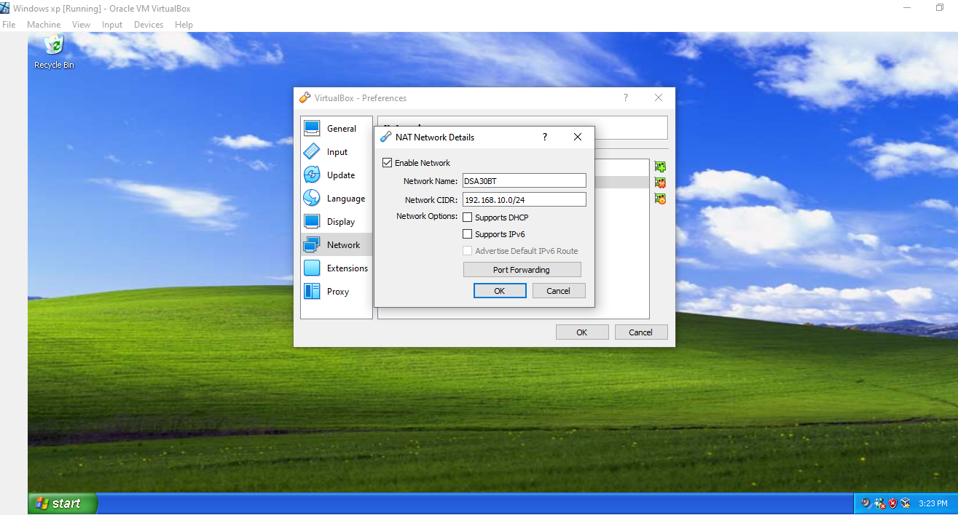

Network IP address connected

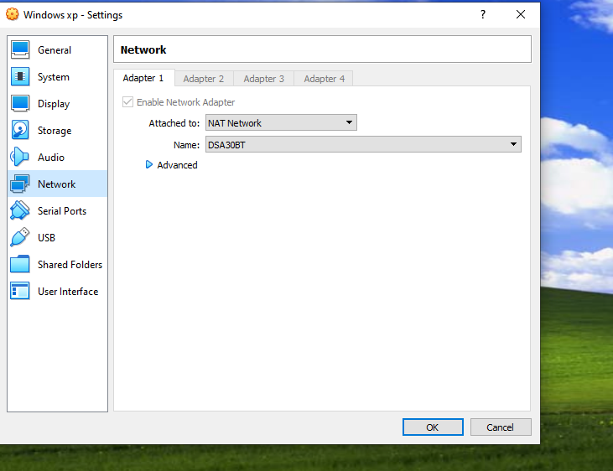

Setting nat address on server vm

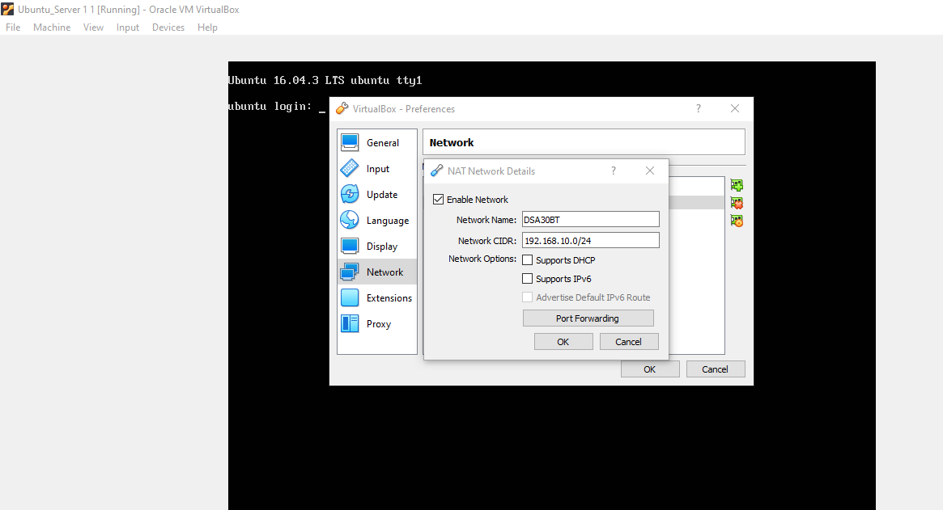

Server nat address connected

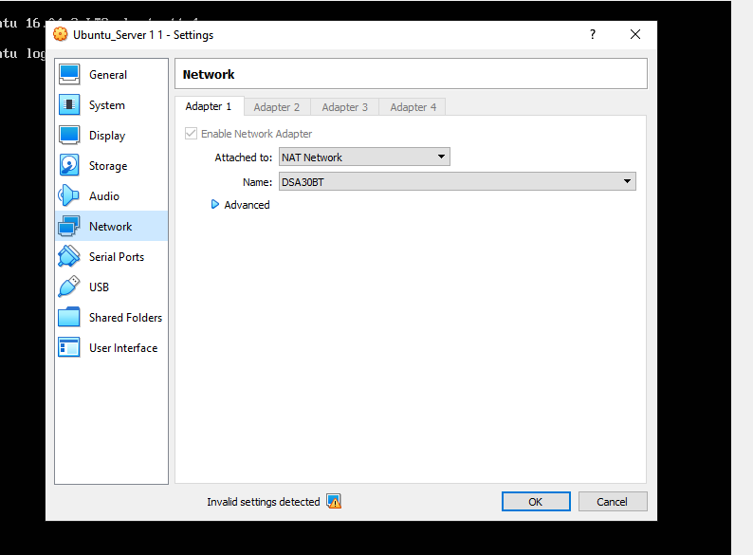

**Task 3: testing connectivity**

-The screenshot below demonstrates how we assigned an ip address to windows vm

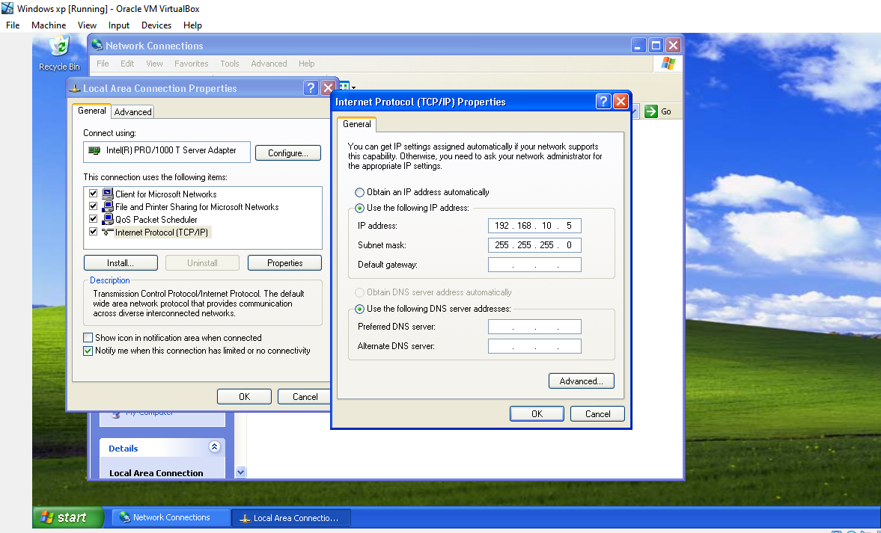

Configuring IP address on server

* The Ubuntu server has no assigned ip address
  + We will add ip address to the server and windows vm respectively:
  + sudo ip address add 192.168.10.100/24 broadc 192.168.10.255 dev enp0s3

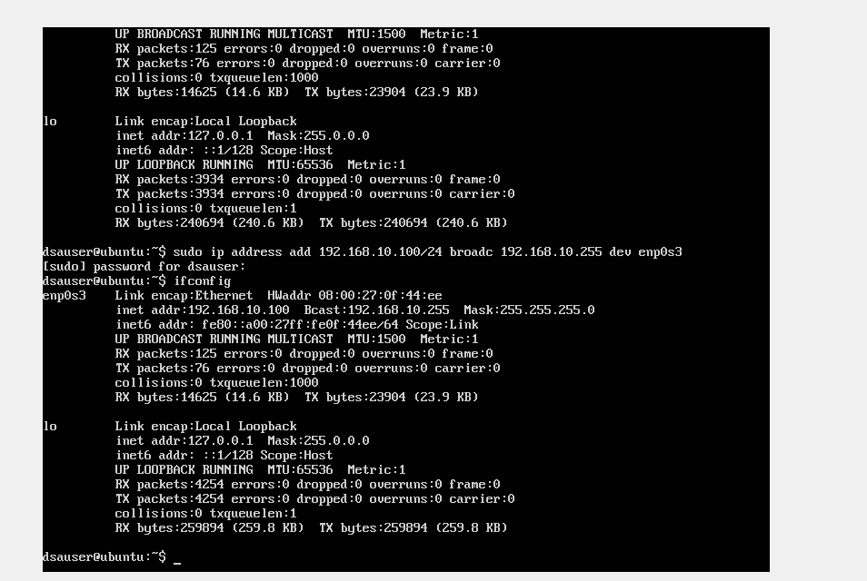

Pinging the IP address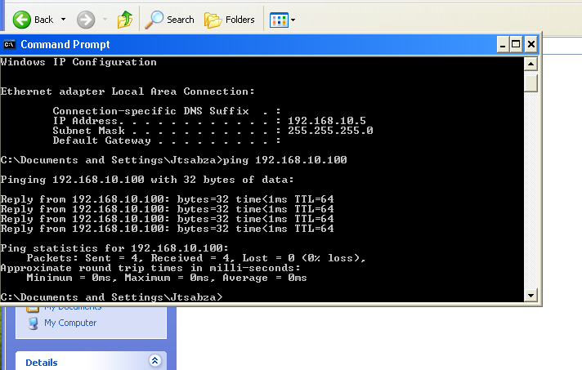

**Task 4: Connect windows VM to ubuntu FTP server and upload a picture**

ftp 192.168.10.100

ftp> Login using given ftp username and password

ftp> Cd ftp

ftp> Cd files

ftp> put linux2.jpg

ftp> quit

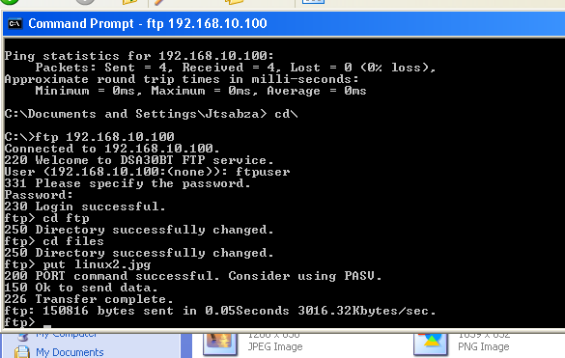

ftp 192.168.10.100

ftp> Login using given ftp username and password

ftp> Cd ftp

ftp> Cd files

ftp> put image.jpg

ftp> quit

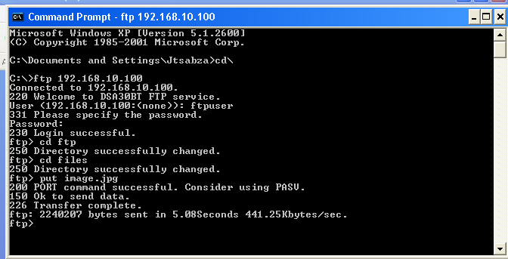

**Task 5: Locate the picture you uploaded to ubuntu FTP server**

We used PuTTy to connect remotely through SSH into the Ubuntu server from Windows VM. We managed to succeed with connecting remotely through SSH into the Ubuntu server.

Steps:

* We first login in as a dsauser and enter the given password.

dsauser@ubuntu:~ cd ftp

dsauser@ubuntu:~$ cd files

dsauser@ubuntu:~$ get linux2.jpg

dsauser@ubuntu:~$ get image.jpg

dsauser@ubuntu:~$quit

**Task 6: Update the web site remotely from windows VM**

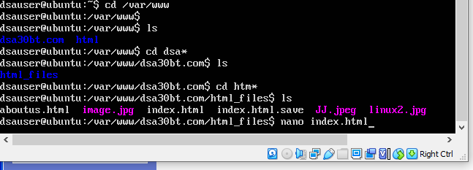

**HTML SCRIPT**

<html>

<head>

<u><b><font color=”white”><title>Welcome to DSA30BT website</title></font></br></b></u>

</head>

<body>

<body bgcolor=”black”>

<font color=”white”><h1><b>This is DSA30BT webpage</b></h1></font></br>

<p>

<img src=”linux2.jpg” />

</p>

<p>

<font color=”white”>for mor info about us <a href=”aboutus.html” >click here </a></font></br>

</p>

</body>

</html>

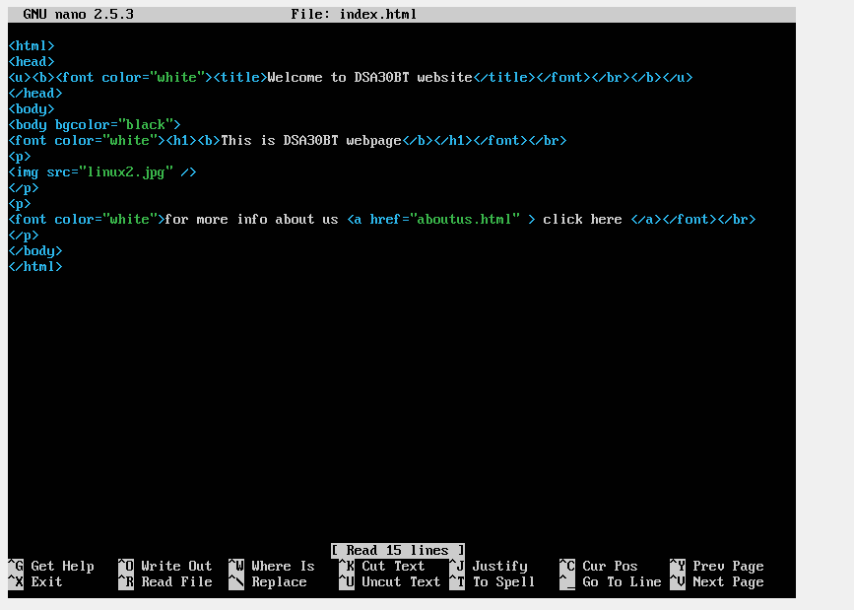

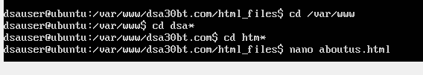

**HTML ABOUTUS SCRIPT**

<html>

<head>

<title>This is developers webpage </title>

</head>

<body>

<body bgcolor=”#3D3D3f”>

<h><b><font color=”#FFFFFF”>This is developers webpafe</font></h1></b>

<p>

<img src=”image.jpg” width=”600” height=”300” /></p>

<p>

<u><b><font color=”#FFFFFF”>These are the group members </b></p></u>

<b><font color=”white”>We are a group of ICT students who specialize in communication networks. We are inspired by innovation. Our aim is to use our skills to best serve the world in the IT industry, connecting worlds, bringing people closer. </font></br>

<p>

<font color=”red”>-Sibiya Samson</font></br>

<font color=”red”>-Dladla Siyabonga</font></br>

<font color=”red”>-Simelane Thulasizwe</font></br>

</p>

</body>

</html>

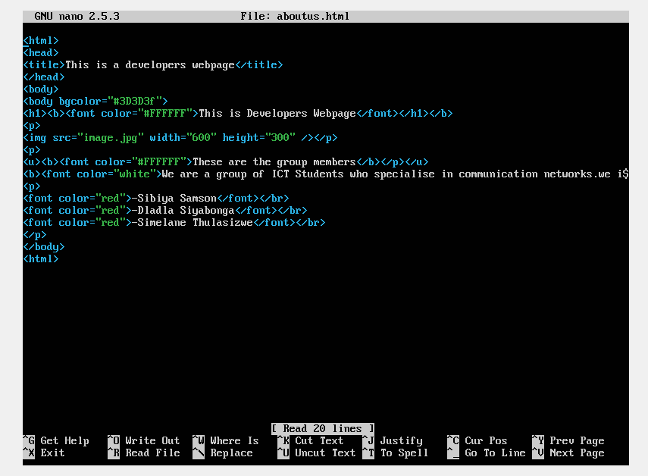

**Task 7: Verify that the website is updated**

Open Internet Explorer web browser on windows vm. Type 192.168.10.100

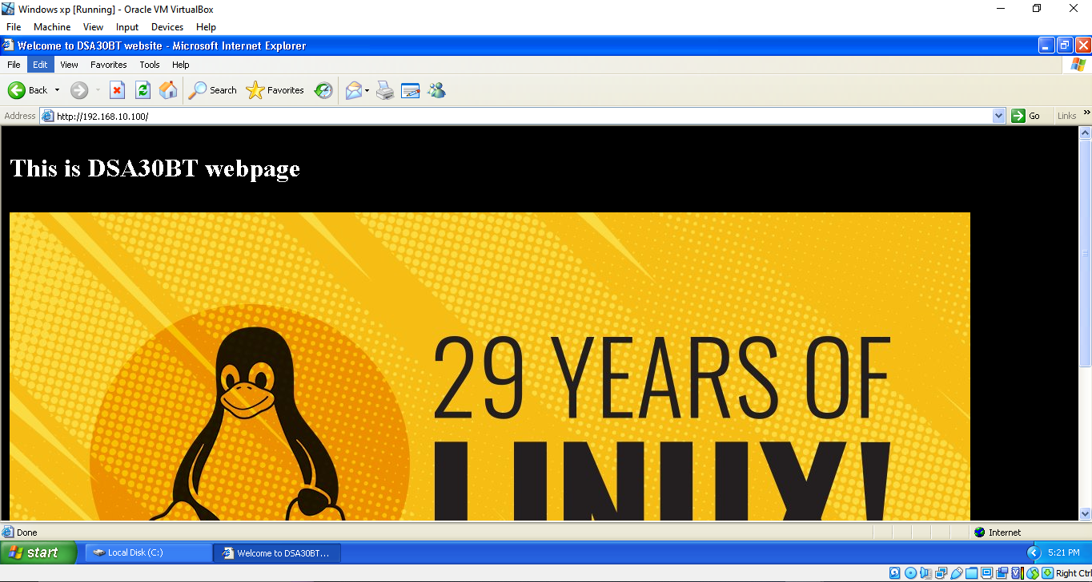

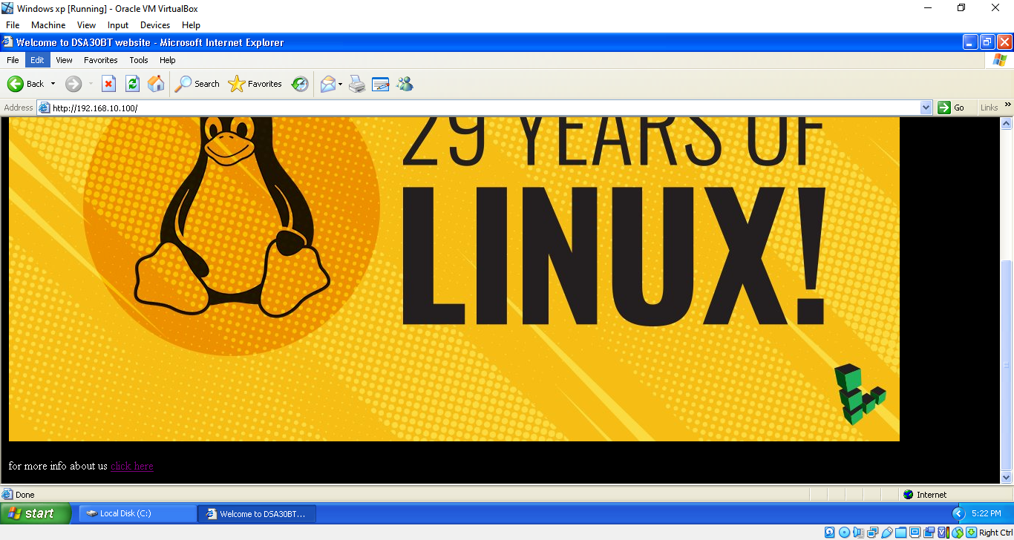

When the “click here” link is clicked, it will take you to this page:

